TASK 1
var subjects = ["Swift", "UIKit", "SwiftUI"]
subjects.append("Networking")
subjects.insert("Testing", at: 1)
subjects.removeAll { $0 == "UIKit" }
print(subjects.sorted())

var registered: Set<String> = ["Anu", "Ben"]
registered.insert("Anu")
print(registered.count)

var marks = ["Anu": 90, "Ben": 80, "Chitra": 95]
marks["Dev"] = 85
marks["Ben"] = 88
print(marks["Esha"] as Any)

for name in marks.keys.sorted() {
print(name, marks[name]!)
}
print(marks.max { $0.value < $1.value }!)

OUTPUT:
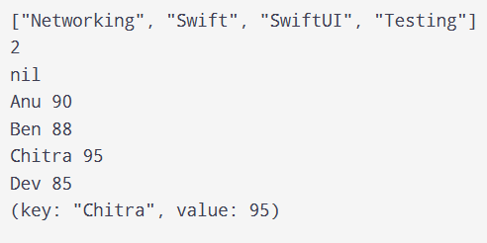
TASK 2
let words = "swift is fun and swift is fast".split(separator: " ")
print(words.count)
print(Set(words))

var count: [String: Int] = [:]

for word in words {
count[String(word), default: 0] += 1
}

print(count)

print(count.keys.sorted {
count[$0] == count[$1] ? $0 < $1 : count[$0]! > count[$1]!
})

OUTPUT:
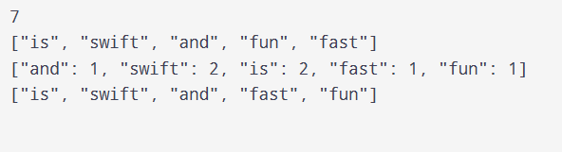

TASK 3
let swiftClub: Set = ["Anu", "Ben", "Chitra", "Dev"]
let uiClub: Set = ["Chitra", "Dev", "Esha"]

print(swiftClub.intersection(uiClub))
print(swiftClub.subtracting(uiClub))
print(swiftClub.union(uiClub))
print(swiftClub.symmetricDifference(uiClub))

let numbers = [3, 1, 3, 2, 1, 4]
var unique: [Int] = []

for n in numbers {
if !unique.contains(n) {
unique.append(n)
}
}

print(unique)

OUTPUT:
